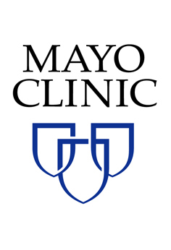 Supply Chain Management
507-266-5551

<Company Name>
<Address Line 1>
<Address Line 2>
<City>, <State> <Zip> Reference ID: <Reference ID>
ATTN: Financial Controller / Chief Financial Officer

<Date>

RE: New Vendor Registration Requirement for all Mayo Clinic supply partners

Financial Controller or Chief Financial Officer:
In an effort to better know our suppliers and maintain government compliance, Mayo Clinic is requiring all of its supply partners to undergo a vendor registration process with Global Edge.
The Global EDGE registration process should only take around 15 minutes to complete. You will be asked to provide basic company information as well as a copy of your most recent W9. Global Edge will verify your company’s information against public records in an effort to authenticate your company. Your company’s registration will allow Mayo Clinic to meet its regulatory requirements by certifying the financial stability, legal compliance and integrity of your organization.
In addition to meeting Mayo Clinic’s regulatory requirements, the Global EDGE platform will provide your company with several benefits including:
- The ability to receive electronic payments from Mayo Clinic which include payment detail from Global Edge via their eNotice process. Electronic payments will allow your company to receive payments faster and more securely while eNotices will ensure your accounting department can properly apply funds.
- A vendor portal which will allow representatives from your company to update your company information and exchange documents with Mayo Clinic.
- The ability to submit an electronic W8/W9 and ensure appropriate tracking of minority suppliers. This information can also be shared across customers that utilize the Global Edge services.
- Reduce your competition from other companies as Mayo Clinic will only utilize vendors that complete the Global Edge registration and receive an “approved status”.
To begin the Vendor Registration process, please visit www.GlobalEDGEGateway.com. Select “New Vendor Registration” and enter the Reference ID that is located in the upper right corner of this letter. If you have questions regarding the Global EDGE program, contact Vendor Support at 1-888-315-0183 or visit www.GlobalEDGE.us to view the full functionality of Global EDGE.
This program should not be confused with our supplier representative credentialing programs and does not mitigate the need for ongoing credentialing of your sales representatives.

Regards,

Kevin J. Maynard
Mayo Clinic – Supply Chain Management

